Pooling Layer in CNN | MaxPooling in Convolutional Neural Network
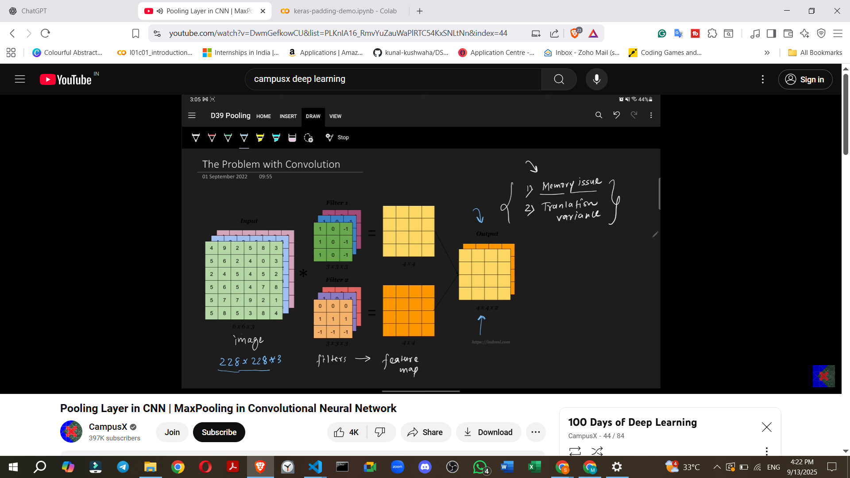

1. Introduction to Pooling
- Pooling is a crucial layer added to a CNN, typically right after a convolutional layer.
- It has several benefits, which are discussed in detail.
- Key questions addressed: What pooling is, why it's needed, and how it's implemented.

2. Why Pooling is Necessary: Problems it Solves
Before understanding the pooling operation, it's important to understand its necessity within a CNN. When applying a convolution operation, two main problems arise:
Problem 1: Memory Issues
- Convolution operations can require a significant amount of memory, potentially causing a program to crash.
- Example: For an input image of 228x228x3 (standard for many good CNN architectures) and applying 100 filters of 3x3x3, the resulting feature map would be 226x226x100.
- If these numbers are stored using 32-bit floating-point values, this single training data point would occupy around 900 MB of RAM.
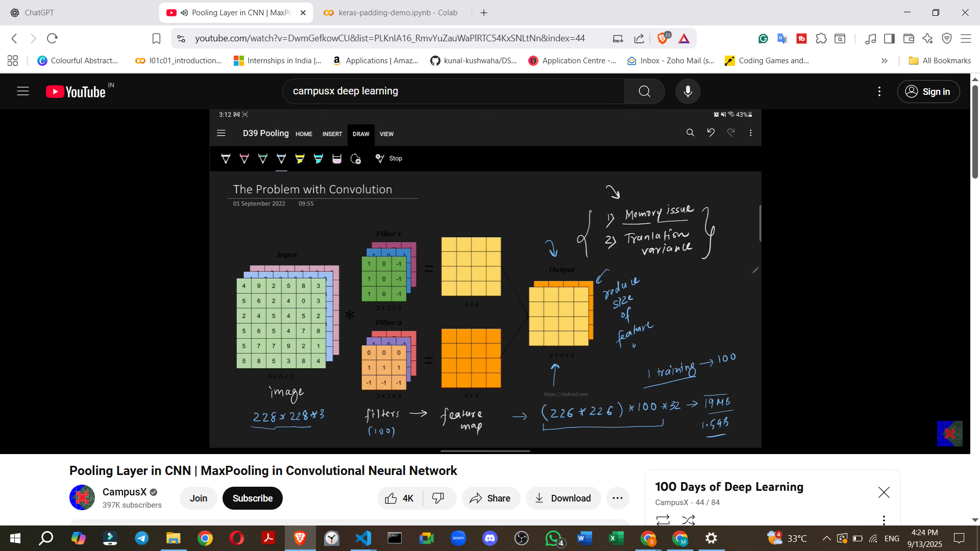
- For a batch size of 4, this could amount to approximately 1.5 GB.
- Conclusion: Such large feature maps are not sustainable, necessitating a reduction in their size.
- One possible solution is to increase the stride in convolution, which automatically reduces the feature map size, but pooling is generally preferred because it also addresses the second problem.
Problem 2: Translation Variance

- Convolution operations exhibit translation variance.
- A convolution operation's purpose is to detect features (e.g., eyes, nose, tail of a cat) in images.
- The problem is that the features detected by the CNN become location-dependent.
  - Example: If a cat's ear is on the left side of the image, features will be detected there. If it shifts to the right, features will be detected on the right.
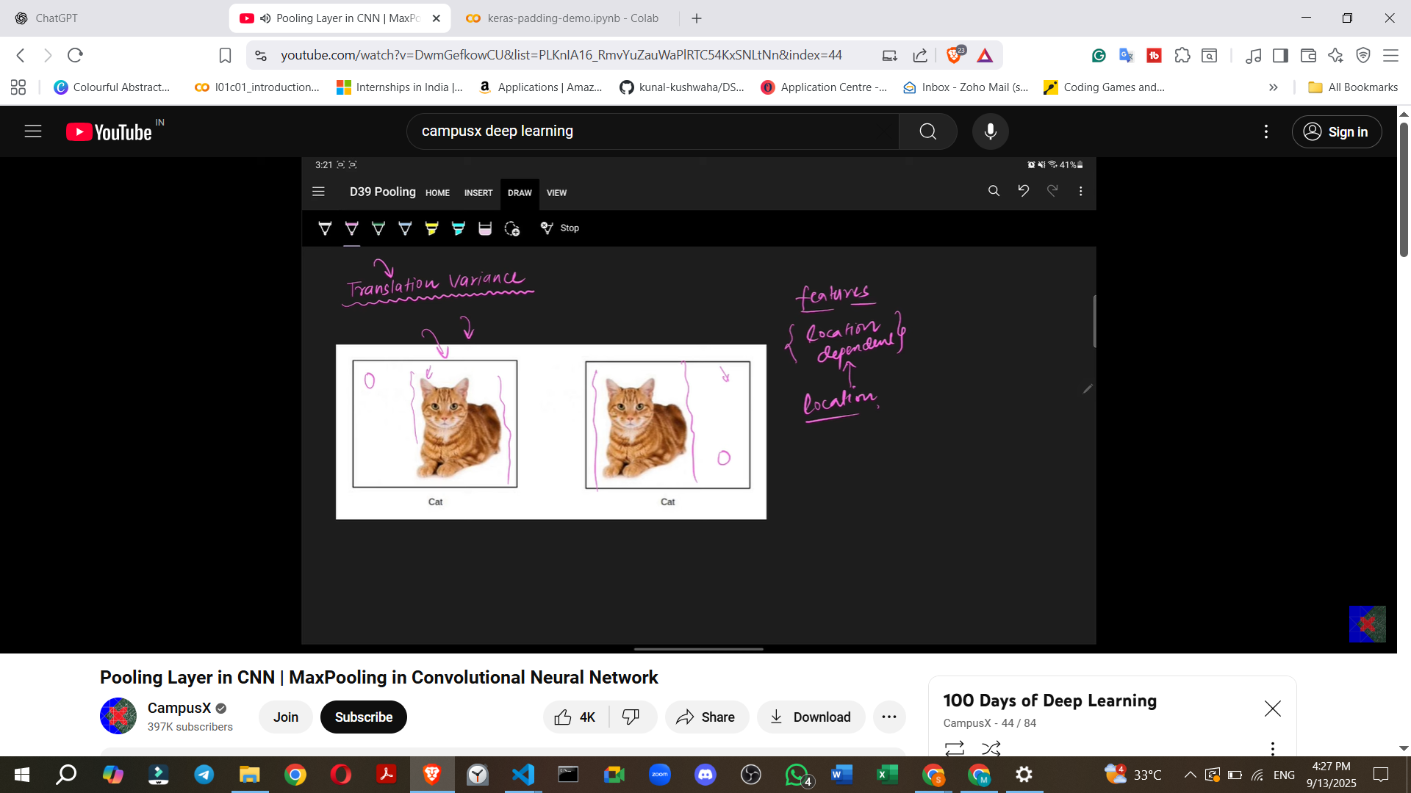
- In image classification tasks (e.g., identifying a cat), the location of a feature does not matter; what matters is the presence of the feature itself.
- If features are location-dependent, subsequent layers might treat the same feature in different locations as distinct, leading to incorrect results.
- Desired outcome: Translation Invariance, meaning that the location of a feature does not affect its identification or treatment by the model. Pooling helps achieve this.
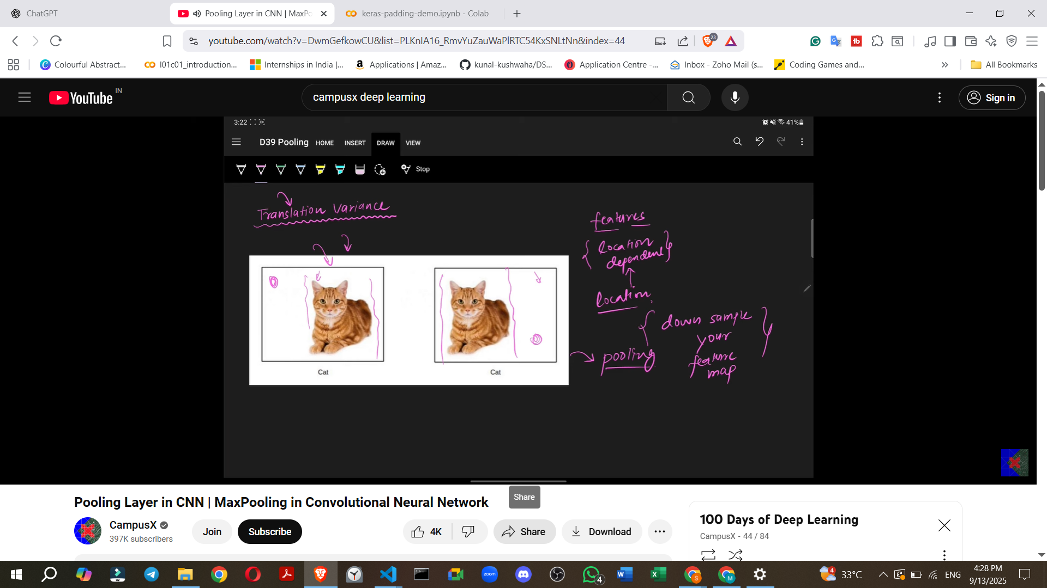

3. What Pooling Is and How It Works
- Pooling is fundamentally a downsampling operation.
- It reduces the size of your feature map.
- Position in a CNN: A pooling layer is generally added after a convolutional layer.
  - Image input
  - Filter application (Convolution operation)
  - Feature Map generated
  - Apply a non-linearity (e.g., ReLU operation) to the numbers in the feature map (negative values become zero, positive values remain).
  - Apply a pooling operation.
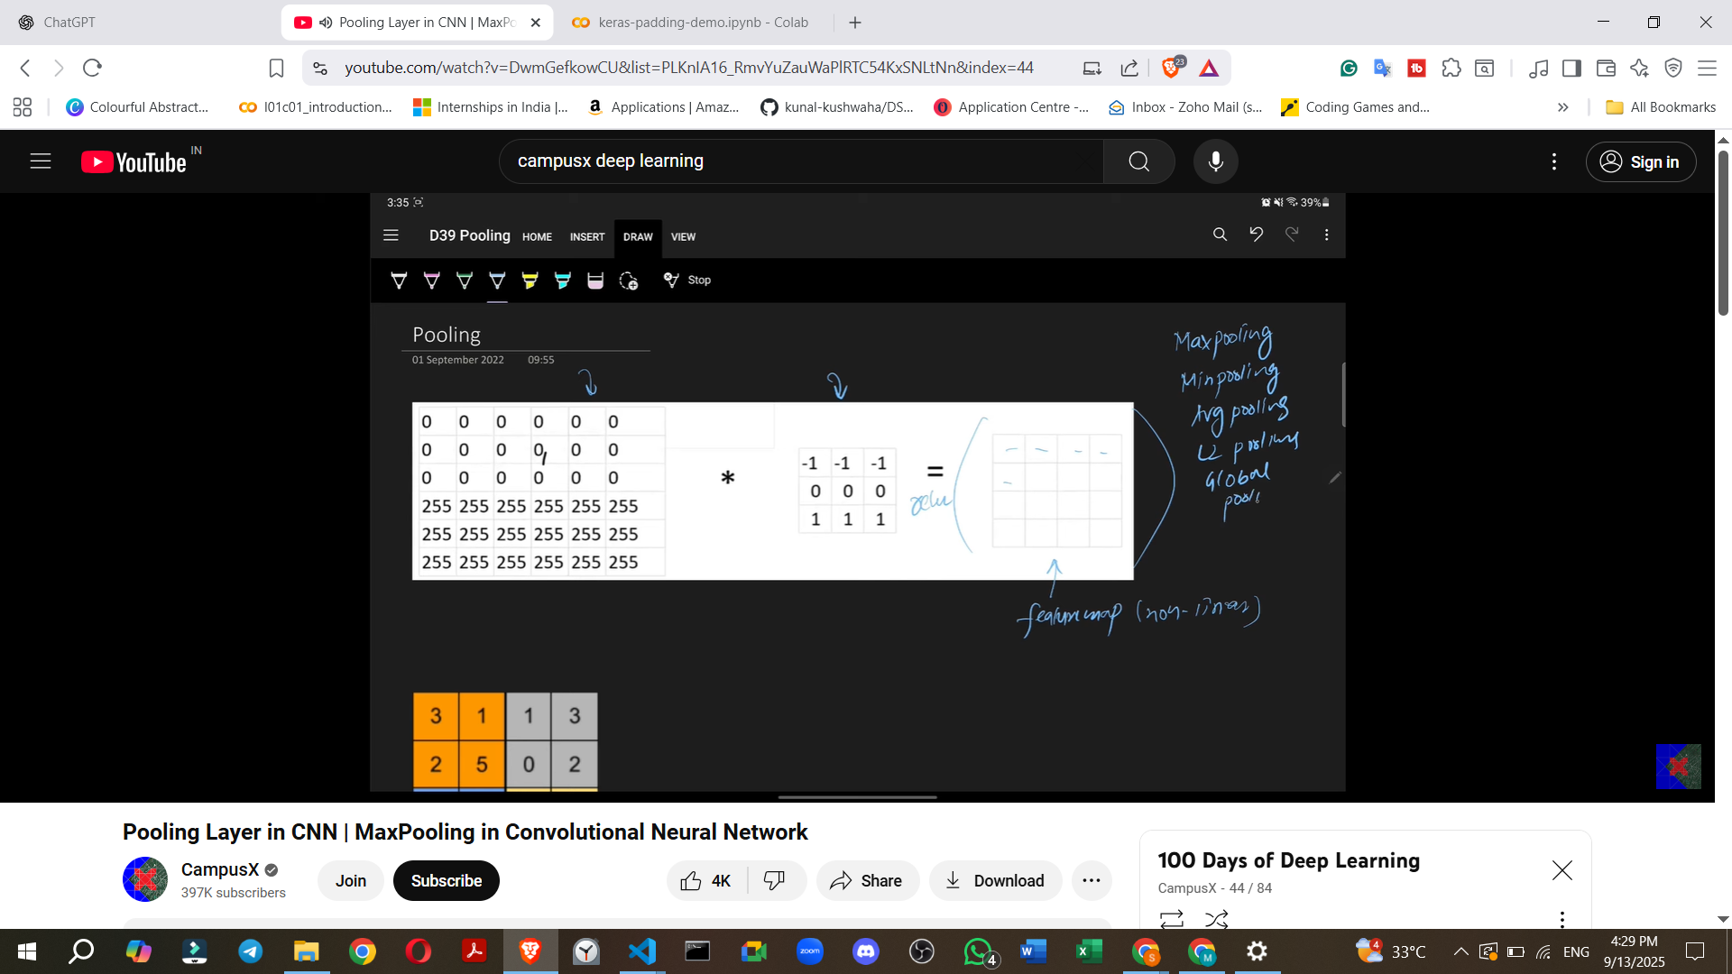
Types of Pooling Operations:
- Max Pooling (most famous and commonly used).
- Mean Pooling.
- Average Pooling.
- L2 Pooling.
- Global Pooling.
How Max Pooling Works (Detailed Example):
- Suppose you have a 4x4 feature map with numbers.
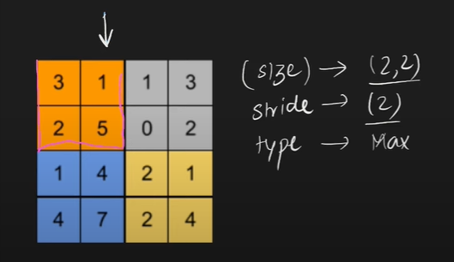
- To apply a pooling operation, you specify three things:
  - Window Size: Typically 2x2, but can be changed.
  - Stride: Typically 2, but can be changed.
  - Type of Pooling: e.g., Max Pooling.
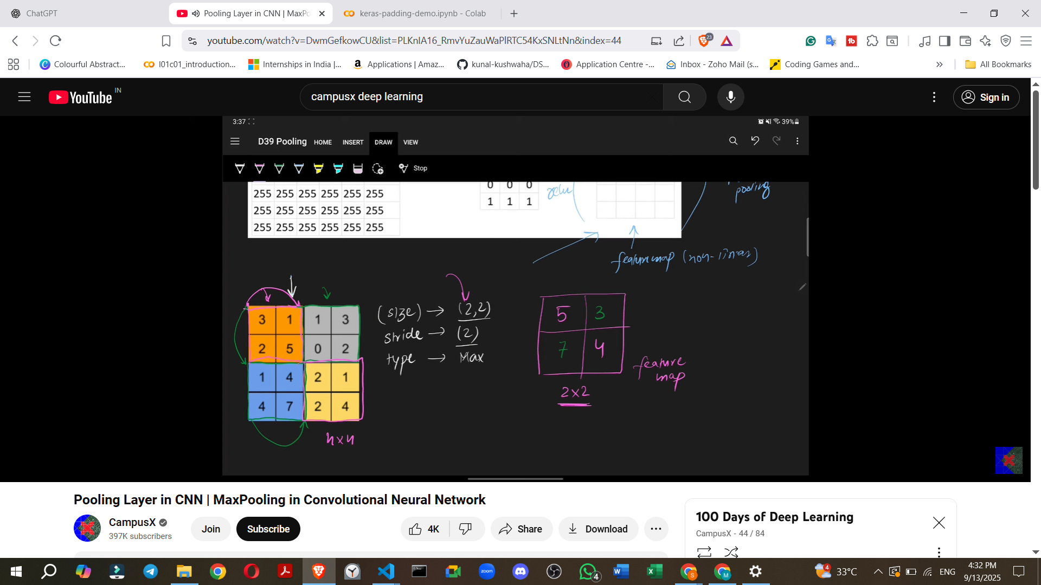
- Process for a 4x4 feature map with 2x2 window and stride 2 using Max Pooling:
  - Take the first 2x2 window. From the four numbers within this window, select the maximum value.
  - Move the window according to the stride (e.g., stride 2 means move two steps to the right/down).
  - Repeat the process: take the next 2x2 window, find the maximum value.
  - Continue across and then down the feature map.
- Result: A 4x4 feature map is reduced to a 2x2 feature map.
- Intuition for Translation Invariance with Max Pooling: Max Pooling works by taking a small area (receptive field) and only keeping the most dominant feature within that area, discarding less dominant (lower-level) details. By downsampling the image this way, it effectively makes features location-independent.
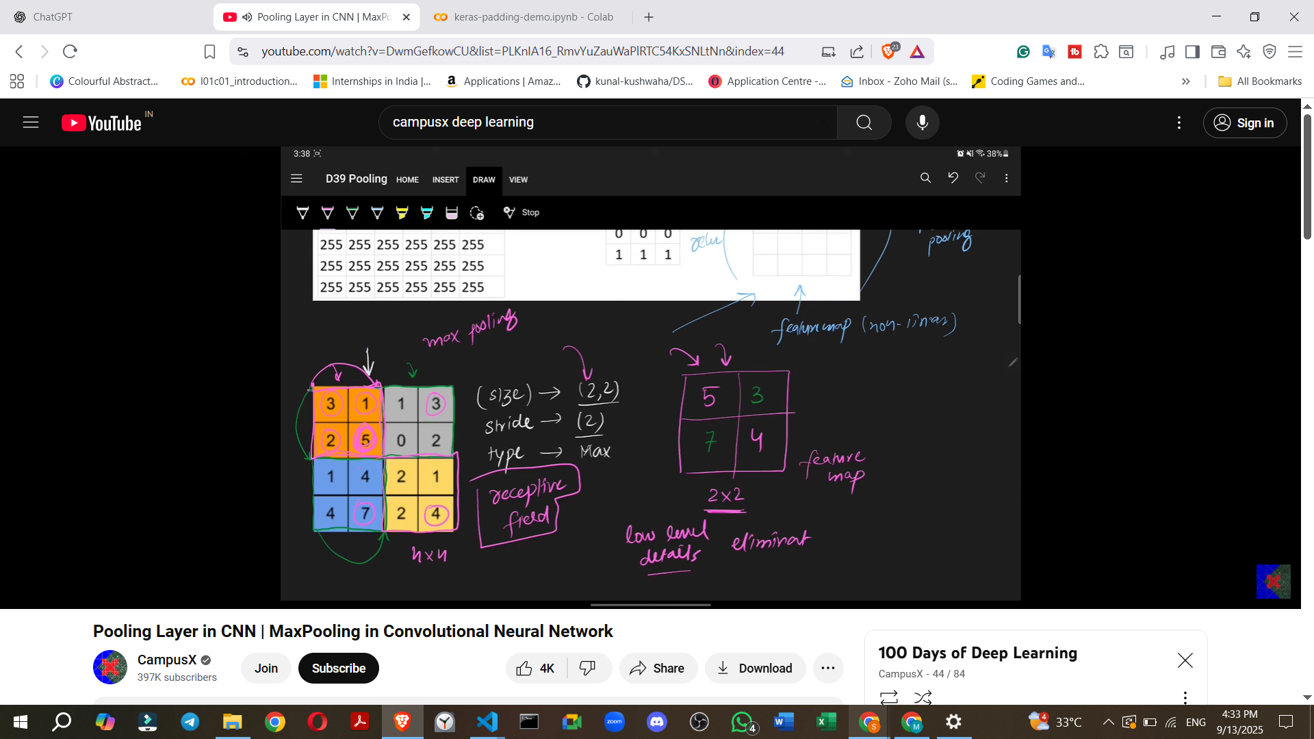
- How Mean Pooling works: You would take the minimum value from the window.
- How Average Pooling works: You would calculate the average of all four numbers in the window.
- How L2 Pooling works: You would calculate the L2 norm of the numbers in the window.
- Demonstration: An online demo (e.g., dblazr.com) can visually illustrate how pooling works, showing the downsampled version of a feature map and how higher-level features are preserved while lower-level details are ignored.
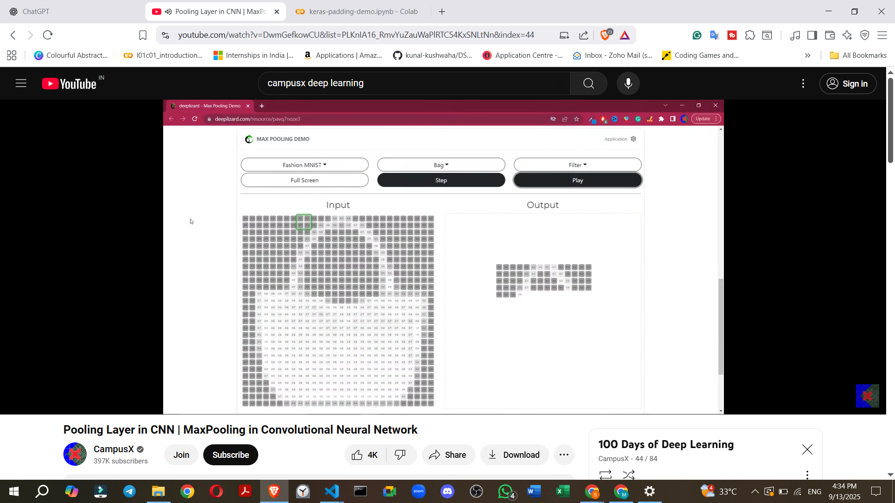
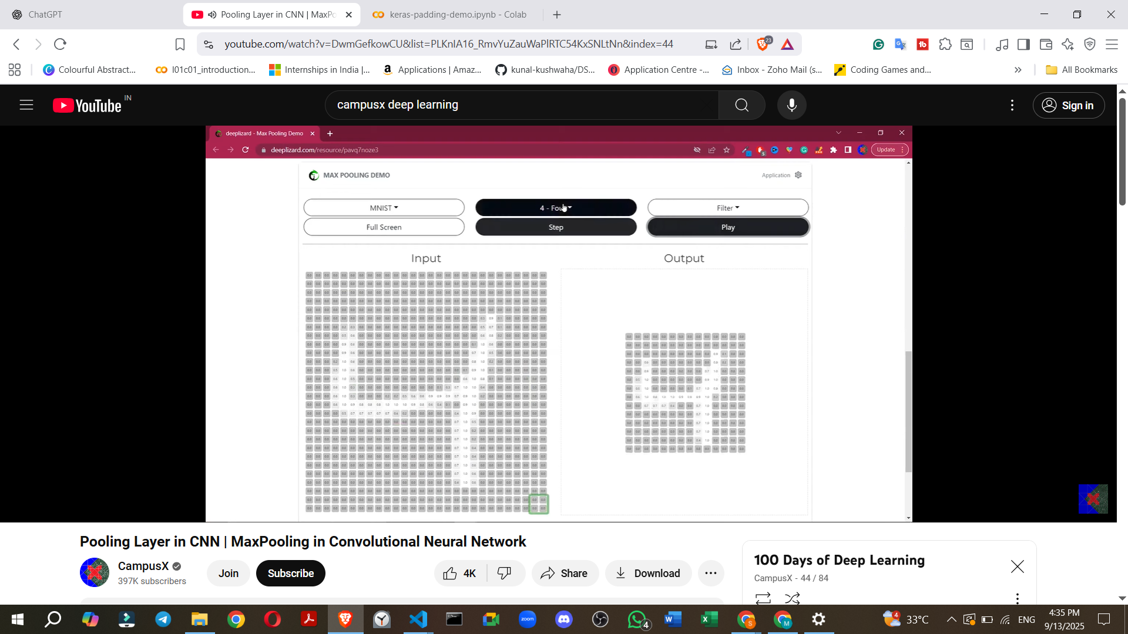
https://deeplizard.com/resource/pavq7noze3

4. Pooling with Multiple Feature Maps (Volume)
- If you are working with an RGB image and apply multiple filters, you will have multiple feature maps (a volume).
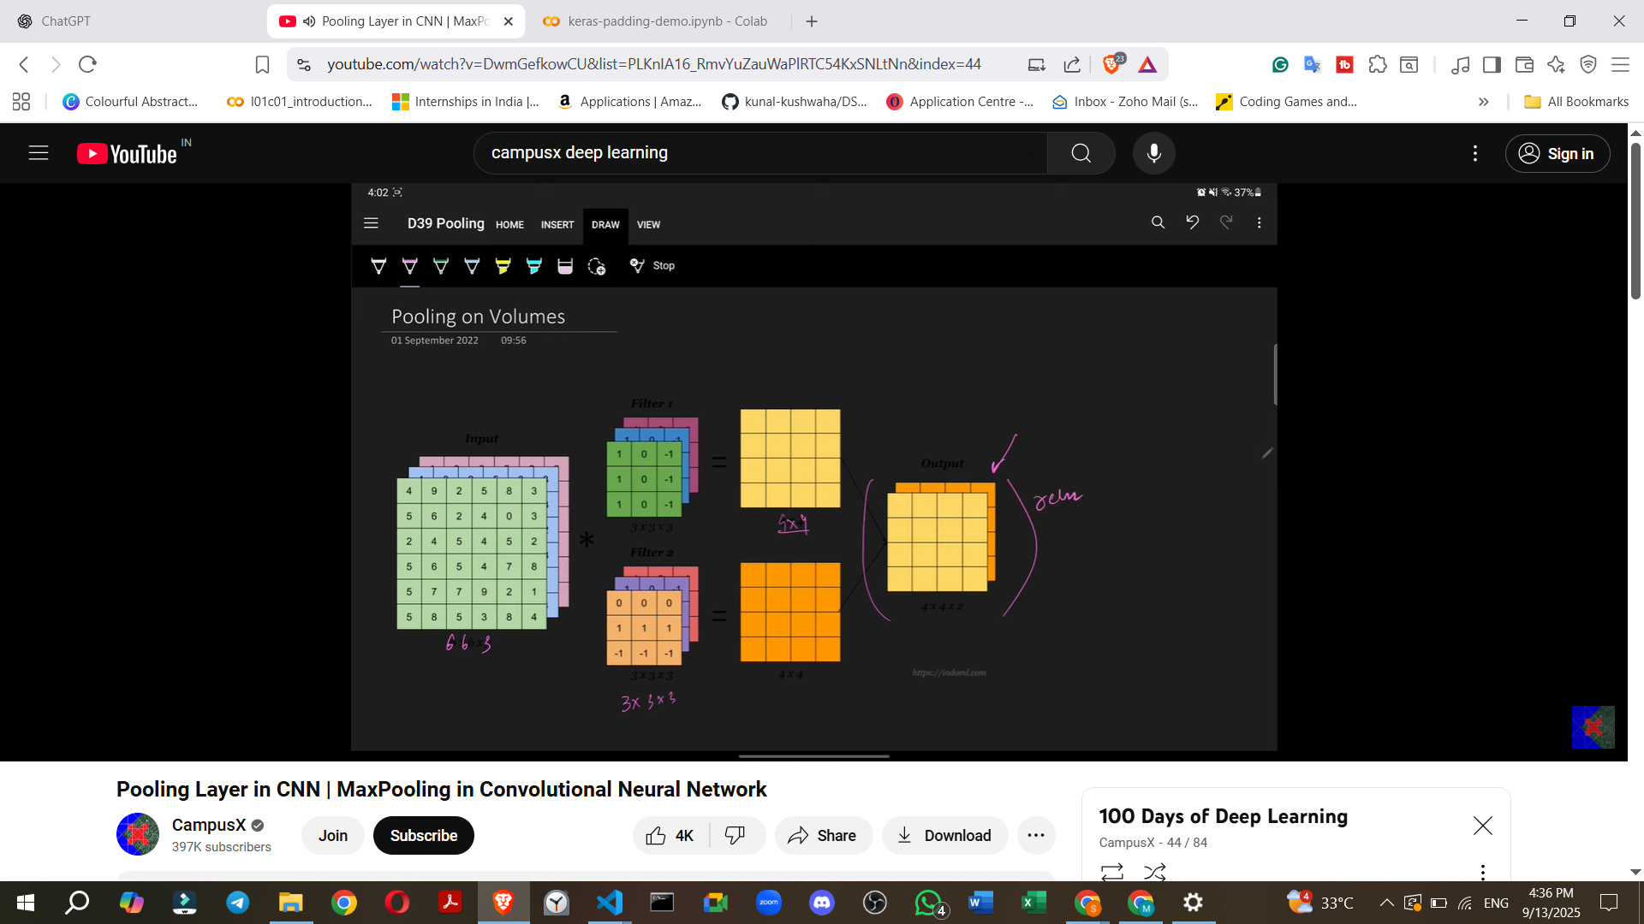
- How pooling applies: Pooling is applied to each individual feature map separately.
  - Example: If you have two 4x4 feature maps, you would apply pooling to the first 4x4 map, then to the second 4x4 map.
  - The result would be two 2x2 feature maps, maintaining the depth (number of feature maps).
- If there were 100 feature maps (e.g., 4x4x100), pooling would be applied 100 times, resulting in 2x2x100 feature maps.
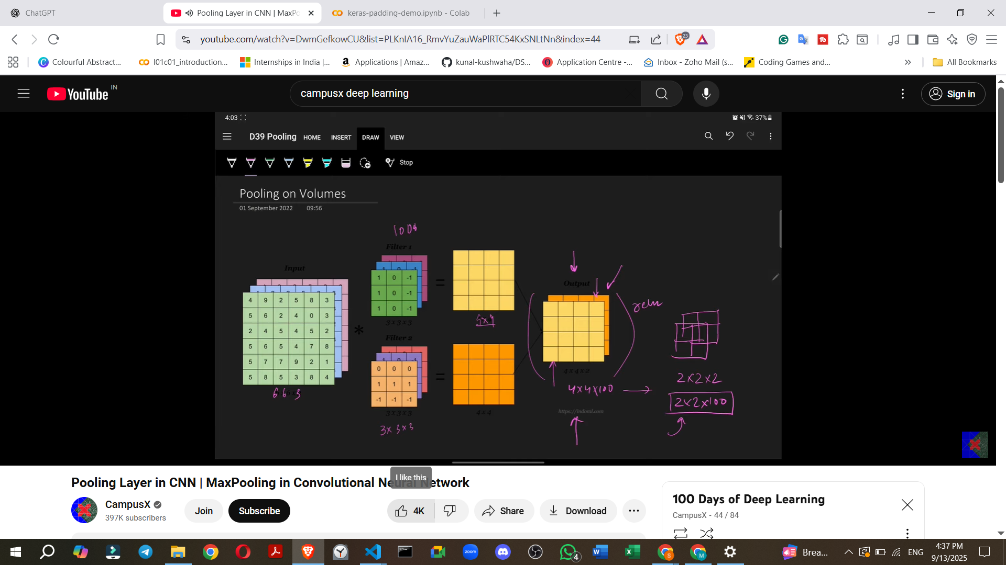

5. Pooling in Keras (Example)
keras-pooling-demo.ipynb
- Keras provides a MaxPooling2D class for implementing max pooling.
- When defining the layer, you specify the pool_size (window size) and strides.
- Example Keras Model Summary:
  - An initial image of 28x28 would go through convolution and become 26x26x32 (if 32 filters are used).
  - After applying MaxPooling2D with pool_size=(2,2) and strides=(2,2), the size would halve to 13x13x32.
  - This pattern continues, further reducing the dimensions after subsequent convolution and pooling layers (e.g., to 11x11x32 then 5x5x32).
- Key observation: Pooling layers (MaxPooling2D in the summary) show zero trainable parameters. This is because pooling is an aggregate operation that doesn't learn weights, unlike convolutional layers.

6. Advantages of Pooling
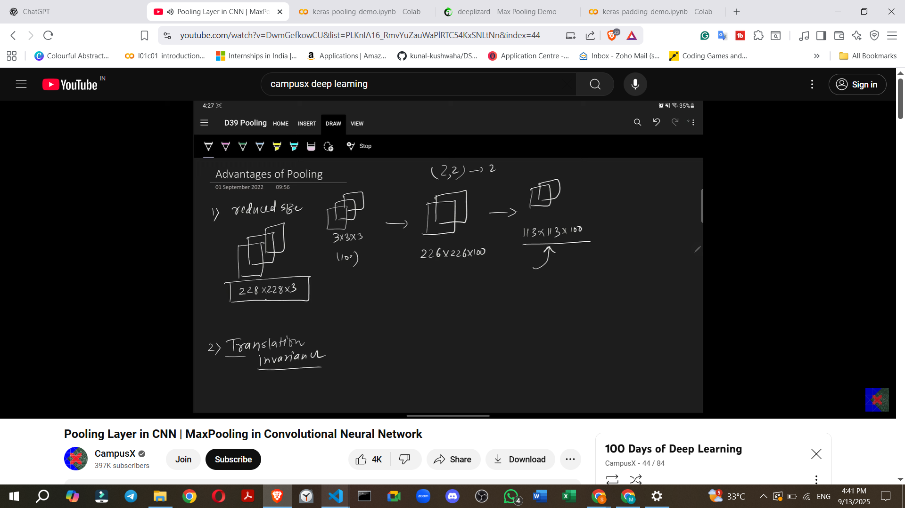
- Reduces the Size of the Feature Map.
  - Example: An input feature map of 226x226x100, when pooled with a 2x2 size and stride, will reduce to 113x113x100. This significantly reduces memory footprint.
- Achieves Translation Invariance.
  - The model becomes less sensitive to the exact location of features, focusing on their presence.
  - Example: Two images of the digit '8', slightly shifted in position, will produce nearly identical feature maps after Max Pooling, demonstrating translation invariance. This is beneficial for tasks like image classification where location doesn't matter.
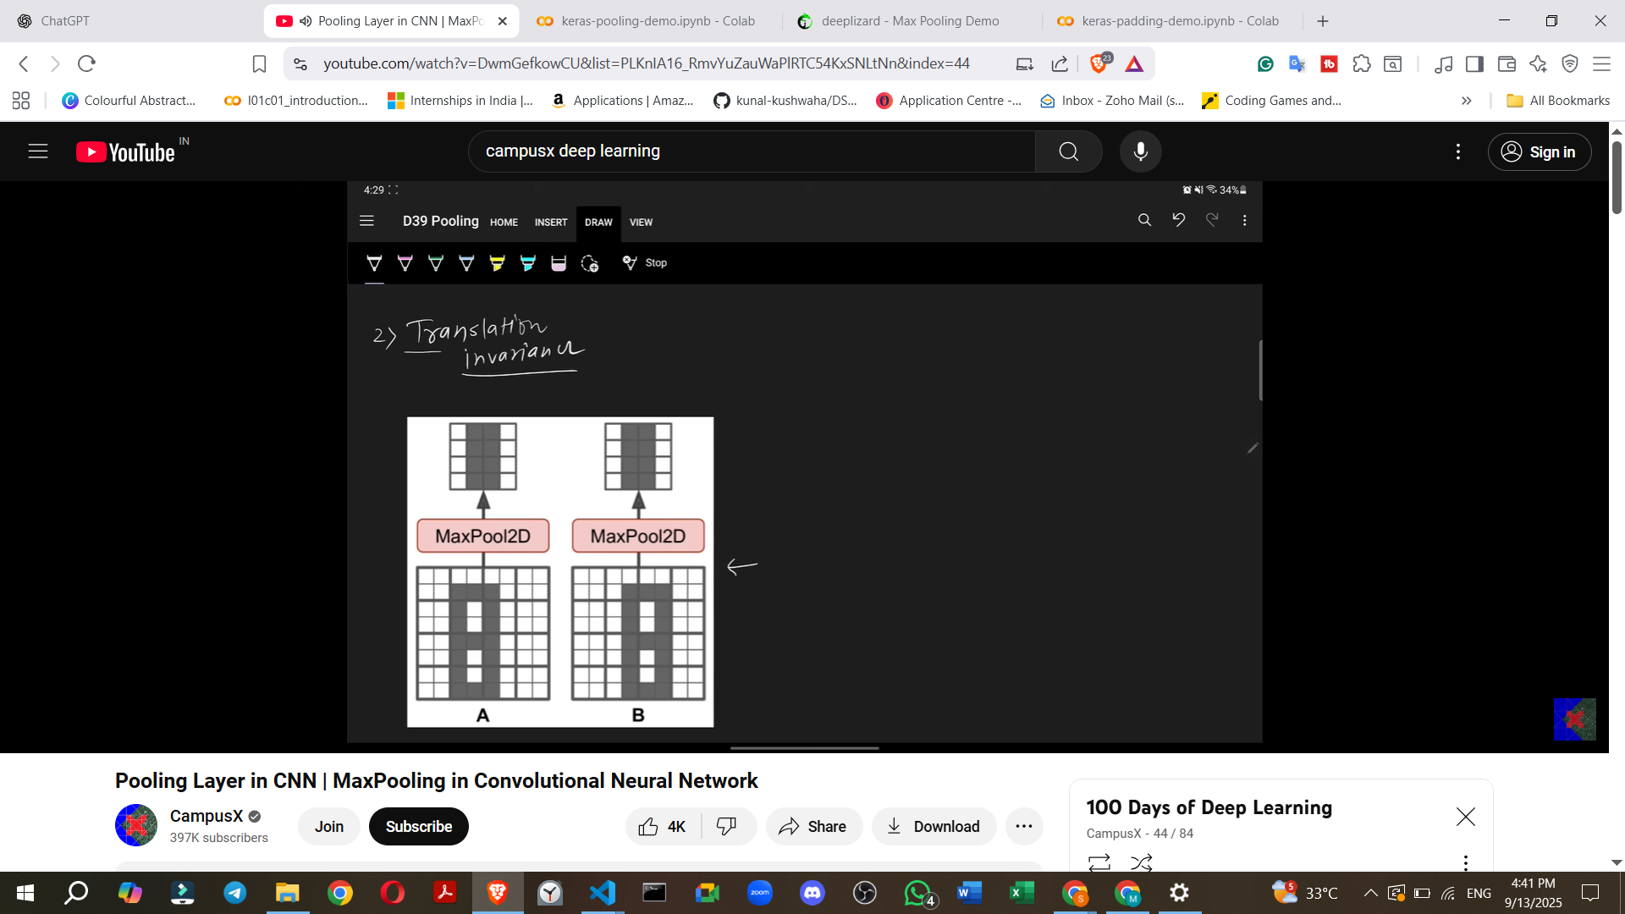
- Enhances Features (Specific to Max Pooling).

  - Max Pooling works by extracting the most dominant features from a local receptive field.
  - This process can result in a feature map where the detected features appear more pronounced or "bright". Other pooling types like Mean Pooling do not offer this specific advantage.
- No Need for Training.
  - Pooling layers perform a simple aggregation (e.g., finding the maximum, minimum, or average).
  - They do not have trainable parameters (weights) that need to be learned through backpropagation, making them computationally faster.
  - You only need to define the local receptive field (window size), stride, and the type of pooling.
  - This makes pooling faster and generally more effective than simply increasing the stride of convolutional layers for size reduction.

7. Types of Pooling Layers in Keras (Detailed)
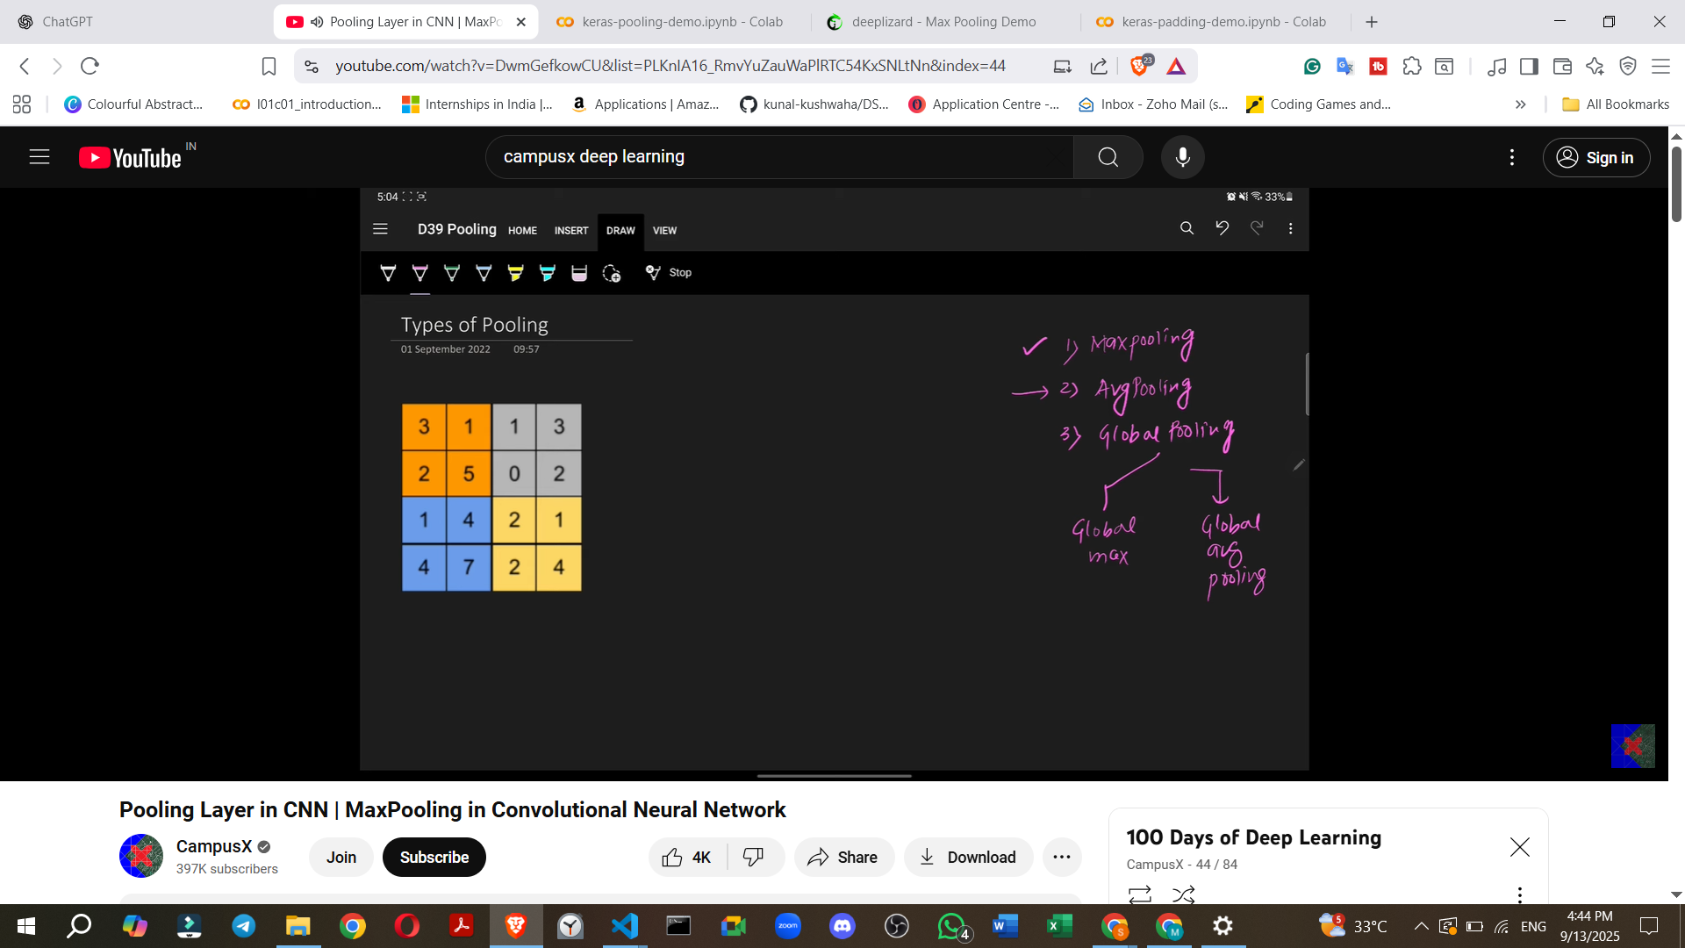
Keras typically offers three main types of pooling layers:
- Max Pooling: (Already discussed as the most common).
- Average Pooling:
  - Very simple: You calculate the average of the numbers within the pooling area.
  - Example: For a 2x2 window, you sum the four numbers and divide by four.
- Global Pooling Layers:
  - Instead of a small window, global pooling takes the entire feature map and reduces it to a single value per feature map.
  - Global Max Pooling: Takes the maximum value from the entire feature map.
  - Global Average Pooling: Calculates the average of all numbers in the entire feature map.
  - Application with multiple feature maps: If you have 4x4x3 feature maps, applying global max pooling would result in 1x3 numbers (one maximum value for each feature map).
  - Use case: Global pooling is often used at the end of a CNN architecture, before flattening and passing data to fully connected layers. It helps reduce overfitting.
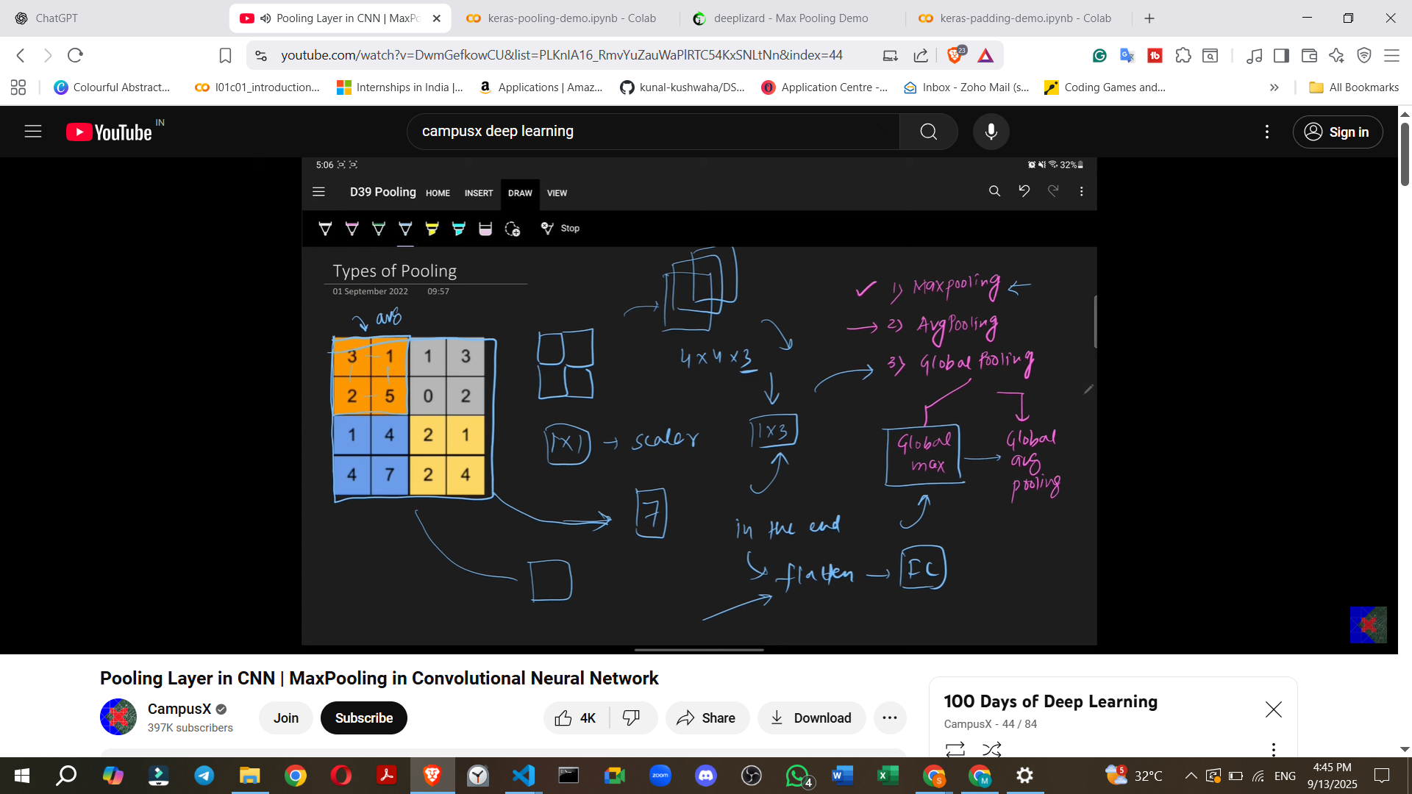

8. Disadvantages of Pooling
While beneficial, pooling has its drawbacks:
- Not Suitable for All Tasks (Location Matters).
  - The translation invariance provided by pooling is excellent for image classification (where "cat or not cat" is the question, not "where is the cat?").
  - However, for tasks like image segmentation (dividing an image into distinct regions), the location of features is crucial. In such cases, pooling may not be used as extensively.
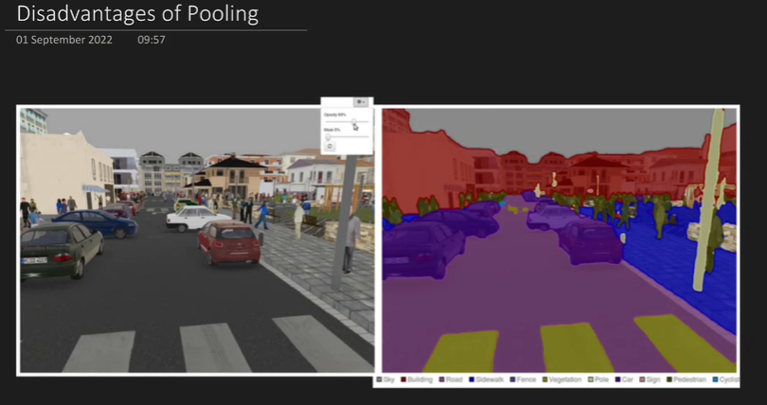
- Loss of Information.
  - Pooling is a downsampling operation that discards a significant amount of data.
  - Example: Reducing a 4x4 feature map to 2x2 means you are retaining only 4 out of 16 values, effectively losing about 75% of the information.
  - Whether this information loss is detrimental or acceptable depends on the specific application being built.
  - It's worth noting that some research papers have shown that respectable accuracies can be achieved in CNNs even without pooling, relying solely on convolutional layers.
Despite these disadvantages, pooling remains an interesting and actively researched idea in deep learning.

